**Sri Lanka Institute of Information Technology**

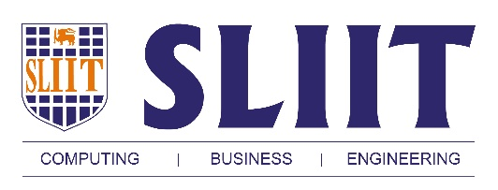

Business case for an Information Security Management System (ISMS) based on the ISO27k standards

**ID: IT13036812**

**Name: U.P.D. De Silva**

**Introduction**

Information security is really important for Virtusa which is a leading provider of information technology solutions in Sri Lanka.

Employees and clients of the organization require to access information systems in order to interact with the services. High availability is expected from these systems and security of these systems are very important as these systems are working with valuable and privacy information. Also the network used to share and transfer information should be secured in order to prevent loss of valuable data and maintain confidentiality.

ISO 27001 Information Security Standards will help the organization to maintain a firm control of its information, improve security of information and reduce the risk of damage to data or loosing data. Investing in developing an Information Security Management System (ISMS) is a great step when considering the future prospects of the organization.

**Benefits**

ISO 27001 ISMS will introduce professional and standardized risk management to the organization. Internationally recognized good security practices will help the organization to reduce security risks by identifying its risks, threats and vulnerabilities. Databases, workstations in the organization will be secured,

ISMS will ensure that only the authorized parties will get access to the relevant information. This will avoid financial losses due to data breaches.

Provides a security baseline in order to identify security requirements of the organization. ISMS helps the organization to identify correct security requirements and appropriate cost for allocating resources to identified risk management. Also it is really important to identify the security requirements of the organization in order to manage (avoid, mitigate, transfer, accept) the risks properly. It will also cut out unnecessary costs.

ISO 27001 is globally recognized. Therefore it adds brand value to the organization. It helps to improve the image of the organization as a trustworthy and well managed business partner.

**Costs**

* Management Costs

Create a Project Management Team. Identifying the risks and prioritizing them.

Schedule meetings with the stakeholders when preparing the security management system.

Skilled technical personal for cyber security should be hired.

Monitor and manage the system once the ISMS is implemented.

* Implementation Costs

Identify information assets and assess their security risks.

Modify the current network into a secured network with modern security standards.

Firewalls for server systems should be implemented, anti-virus and anti-malware programs should be installed in the workstations and the existing programs should be updated.

Training programs for the staff to get familiar with newly introduced security system and security procedures.

Timely backups of the information should be maintained.

Security access cards for the authorized personal to access restricted areas like data stores and data warehouses.

* Certification Costs

Consult a suitable body to ensure that the organization meets the certification requirements.

Audits and working time spent by the staff for the certification related activities.